GIT HOL 3
Step 1: Create New Branch
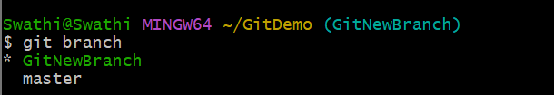
Step 2: List Local and Remote Branches

Step 3: Switch to New Branch
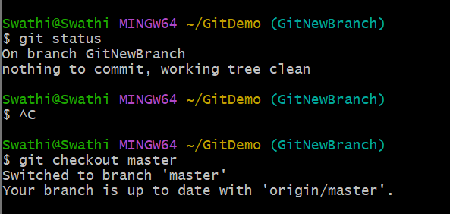
Step 4: Add File with Content
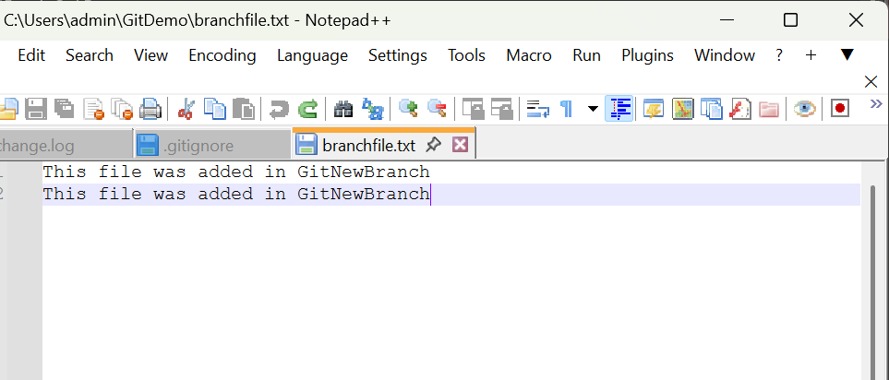
Step 5: Stage the File
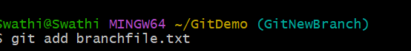

Step 6: Commit Changes on Branch
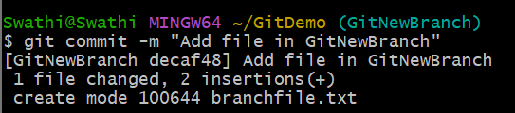

Step 6: Merge Brach into Master
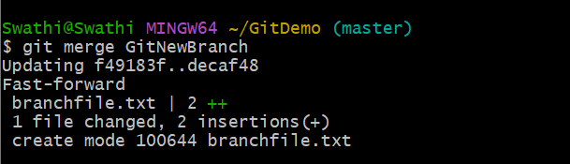
Step 7: View Commit Graph
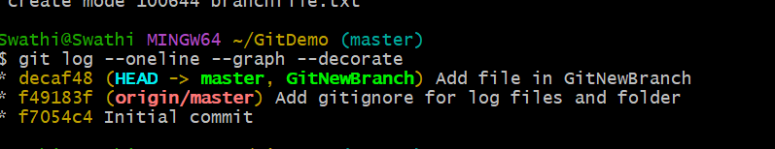
Step 8: Delete Merged Brach
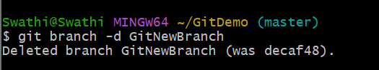
Step 9: Check Status after Deletion
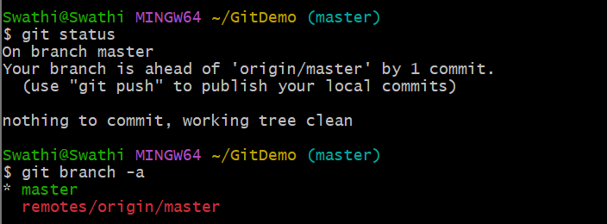
Step 10: Push Merged Changes to GitLab
